Table of Contents

1 Introduction 2

2 Improve operations and marketing 2

2.1 Internalization investigation 2

2.2 Customer-based analysis 2

2.3 Types of handsets analysis 8

2.4 Reviews analysis 10

3 Decisions for CEO 14

3.1 5G 14

3.2 Database 15

4. Conclusion 16

# 1 Introduction

The client company aims to discover the potential of expanding its business abroad. It also wishes to analyse its newly acquired customer-base from a mobile company and explore the possible mobile phone handset they could offer. The company is also concerned of its customer service and wishes to analyse the reviews and complaints they have received. Regarding the demand of the CEO, the client company wishes to gather information surrounding analysis on 5G implementations and database systems to support two decisions of the company. The report will include analysis done with the help of tableau, R, wordclouds, the MCDA model and the EV model. Recommendations will be made after each analysis.

# Improve operations and marketing

2.1 Internalization investigation

About the internalization, in August 2018, Monaco's telecommunications operators signed an agreement to make it the first country in Europe to have full 5G coverage. In the construction of Monaco's 5G network, the blessing of mobile phone equipment in overseas countries has played a vital role. Even South Korea's 5G commercial services also use a lot of equipment from the United States. Although Monaco is a small country, this is indeed an opportunity for our company. Although Monaco is small, it also has a lot of weight in Europe and has a great effect on bringing 5G to the international market. It can serve as a model for other operators and countries.

* 1. Customer-based analysis

According to the bar chart 1, it is obvious that the occupation of Bonnett’s Broadband’s most customer is professional expertise, meanwhile it also illustrates that the occupation information of 37575 customer is unknown. The information is not completed, thus, Bonnett’s Broadband has to do further survey about their customers.

In bar chart 2, the figure of customers income and the time duration of choosing Bonnett’s Broadband’s service are presented. Different color infers to different customer value which range from. To some extent, the figure of “months in service” is tied up with customer loyalty. The customer incomes are range from 0 to 9. In bar chart 3, the vertical axis represents the average income group and the horizontal axis means the credit rating of the customer. Meanwhile, the blue and orange represent whether customer owns a RV or not respectively. Accordingly, the changes among the former five columns of chart 3 illuminate that the highest number of income level is 9 and 0 is the lowest. Apart from the number of different income level, let’s focus on bar chart 2 again. While the average customer income level of the group increasing, the time duration of using Bonnett’s Broadband’s products and customers loyalty are increasing as well. However, the income of the essential customers is attributed to relatively medial or low-income level. Meanwhile, Bonnett’s Broadband also faces a loss of a large number of low-income customers as the chart 2 demonstrates that their using time are normally less than three years. Therefore, it is highly suggested that Bonnett’s Broadband should focus on their after-sales customer service so as to investigate the main reason, such as product pricing, of the customer loss.

Overall, bar chart 4 illuminates that the customer group range from 18 to 37 years are unlikely to buy the phone service through mail while the old prefer buying through mail order. Young people’s negative respond to the mail offer is contributed to their bad performance in buying via mail order and vice versa. Thus, it is essential for Bonnett’s Broadband to advertise and offer products to different customer through different channels, such as use mail to do marketing with people above 38.

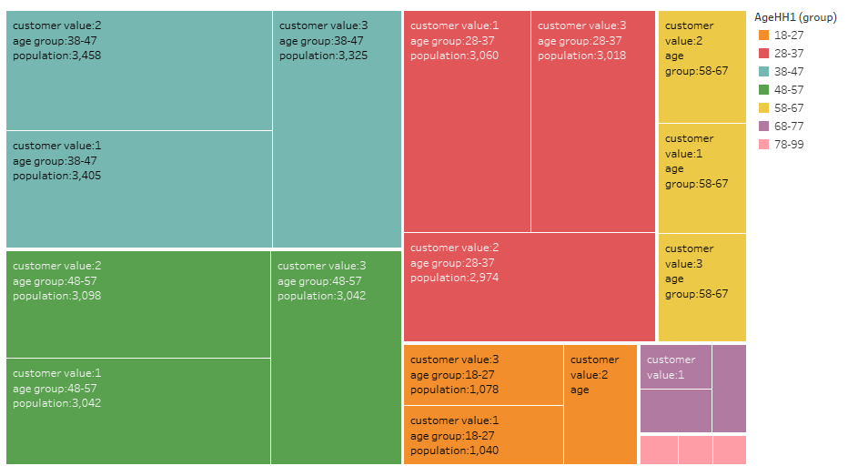

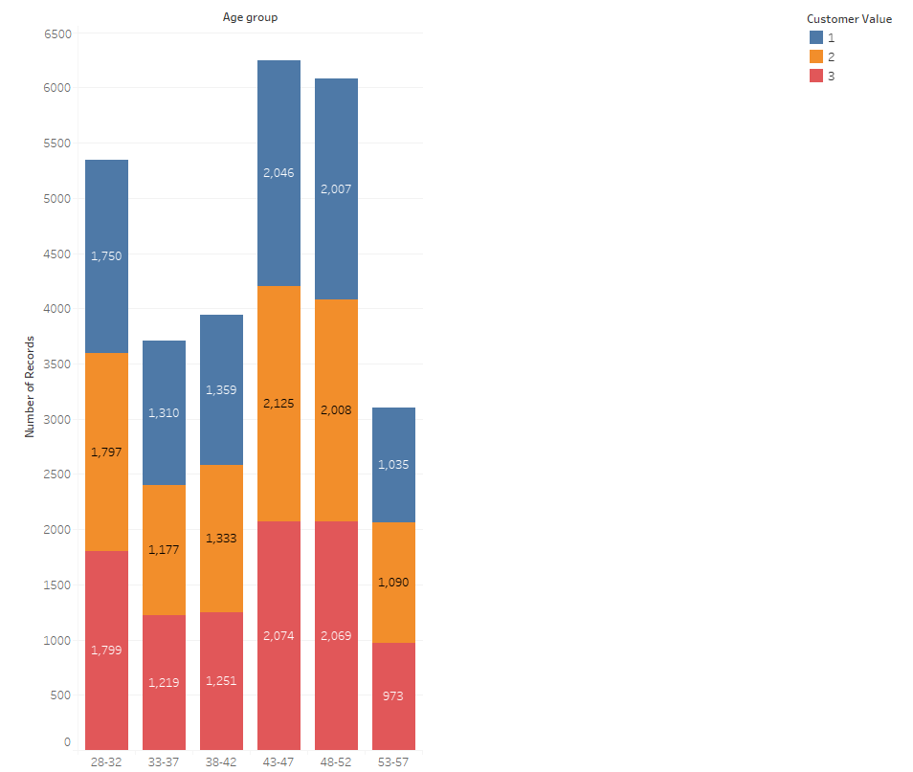

From the graph, we could clear see that the category of 28-32, 43-47 and 48-57year old present the domain positions so that company might target at those customers to achieve a better performance. While the customer value 1, 2 and 3 are basically equal, the contact methods do not need to be improved largely.

## 2.3 Types of handsets analysis

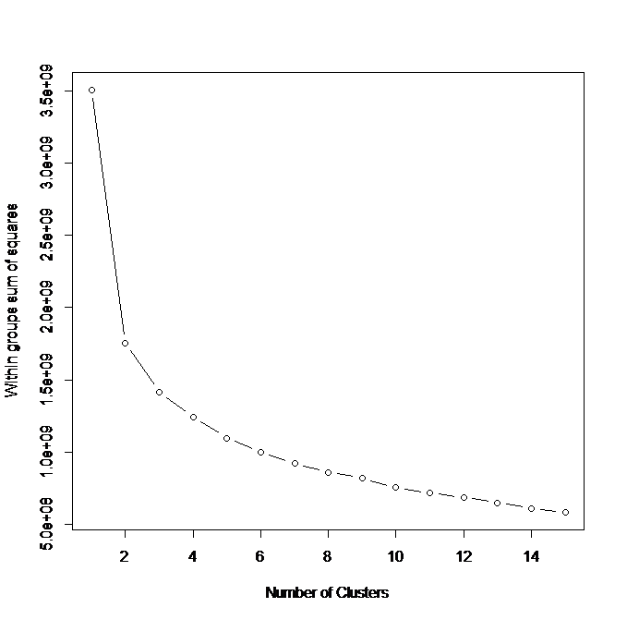

Since the data is complex, the group decided to put the data in six clusters. The reason behind the choice of six clusters is to keep data accuracy and limit the number of clusters at the same time.



We used R coding to conduct K-means clustering and put the data in six clusters. Since the objective is to narrow down specific types of mobile phone handsets, it is necessary to omit useless data, which doesn’t have evident differences in one category. The standard deviation and mean of each column are used to calculate the coefficient of variation. By knowing the coefficient of variation, the difference of data in each column can be defined. A higher value means a higher difference in data. The columns which possess a low variation of data were removed (a/b< 0.1), leaving 5 columns to analyse.



After narrowing it down to five columns, the distance from the mean is calculated. The mean of each column represents the ideal standard for the suitable mobile phone handset. The distance from the mean represents how far it is from the ideal standard. The closer the number is, the more ideal it is to consider.



The MCDA was used to evaluate each cluster. Firstly, the weight of each column was identified by the coefficient of variation. The more differences in data a column has, the more important it is for the evaluation. Points from 1 to 6 were given based on the distance from the mean. The smaller the distance is from the mean, the more points it gets. The points in the five columns were added and the cluster which gained the most points was cluster 3. It can thus be concluded that a mobile phone with a battery power around 1271mAh, a resolution of 375*976, a ram of 2421 MB and a price range around 1.65 is preferred by the customers of the company.

* 1. Reviews analysis

The database of more than 5,000 comments shows us that the low rating comments (0, 1 or 2) is up to 94%, in this case, the reasons of the results are needed to be found individually.

*Figure 1 potation of rate*

To find out the reasons, words cloud which presents the frequency of certain words is significant. In the following results of cloud, the comments of 0, 1 or 2 rates are chosen to acknowledge customers’ complains. Besides, some words that are meaningless such as "broadband", "get", "going" and "bonnets" are ignored. Moreover, we choose 7 cluster since the result of 7 to 10 clusters are similar. Part of the results are presented as following:

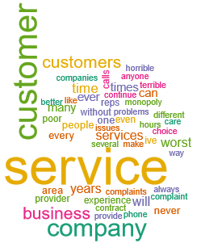

*Figure 2 customers services*

According to the figure 2, words like “customers”, “service” “terrible” and “worst” are mentioned. In this case, the first problem would be the terrible customers’ services.

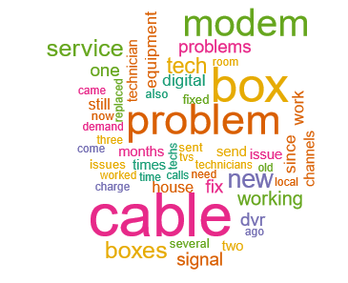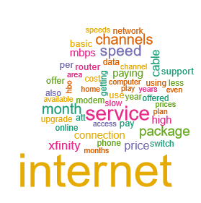

*Figure 3 Internet and cable*

According to the figure3, in these similar topics, “internet”, “service”, “cable”, “speed”, “technician” and “data” are the most popular word, so the problems of the internet have negative impact on the company.

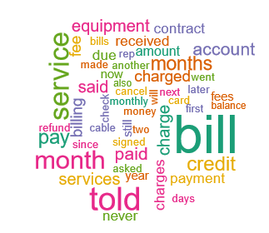

*Figure 4 Bill*

As presented in the figure 4, “bill”, “months”, “fee” and “charged” are mentioned numerously, which means that customers have complained about the fee frequently.

Comparing with the negative comments, the number of positive comments is much smaller. To find out the most popular positive topic, a new k-means on all the data set are run and the cluster is set as 10. Besides, certain words are excluded as before. The result is present as follow:

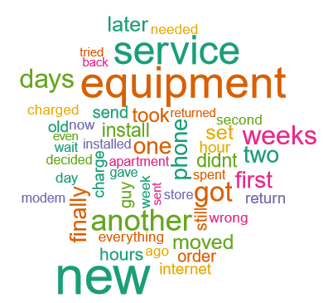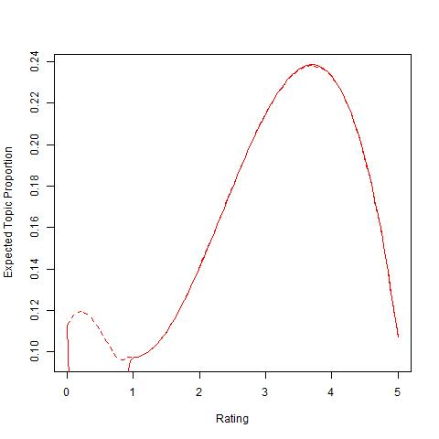

*Figure 5 Positive and regression*

As presented in figure 5, these words cloud has summarized the positive topic according to the regression. It shows that the new equipment and service are highly appreciated by customers. Besides, the modem is mentioned though it is not as frequently as other words.

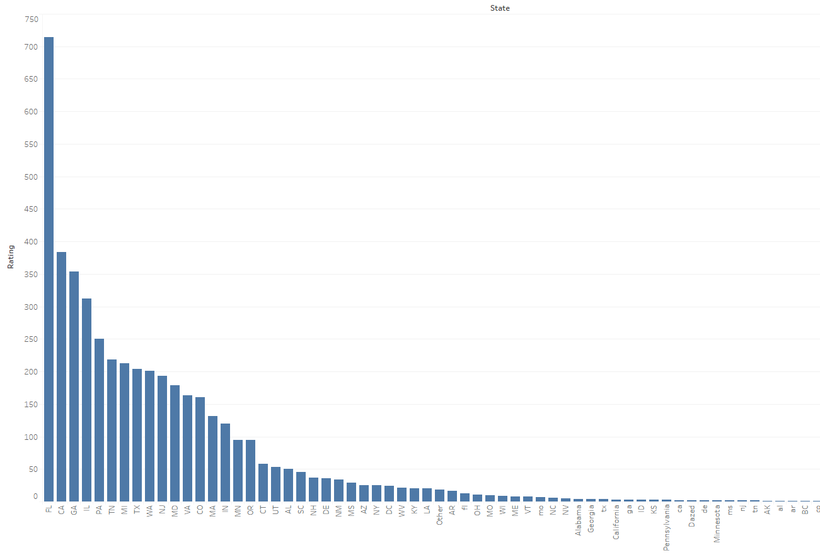

*Figure 6 Rate of states*

What is more, the data shows that the sum of rate is varied in different states, which might be the results of unbalanced distribution of users or varied network situation.

Recommendations:

* The customers’ services should be improved since so many customers complaint on it.
* Some technical problems should be settled as numerous customers are suffering the poor internet speed and it believes that more technicians are needed.
* The company needs to have a new pattern in charging in order to improve customers’ feeling.
* The rate of different states are varied, which means the company should focus more on the low rate states.

1. Decisions for CEO
   1. 5G



To evaluate the 5G implementation of the company, the expected value model was applied to determine the feasibility of an investment. According to the company, after investing £40,000 in technology implementation, there is a 70 percent rate of a success implementation of the technology. On the other hand, the failure of the implementation will result in a £40,000 loss. If the technology works, the company will invest £30,000 in marketing. The company will have a 50 percent commercial success rate which will gain £100,000. If the company fails, it will lose £70,000.

Based on the EV model, the company will lose £1,500 if it decides to invest in 5G. If the company decides not to invest, they won’t lose money. It can thus be concluded that the company should not invest in 5G in order to not lose money.

## 3.2 Database

As the operator said, the database needs to achieve a higher performance because of incorporating with another company now.

|  |  |  |  |  |  |  |
| --- | --- | --- | --- | --- | --- | --- |
| Criteria | Scalability | Availability | Security | Partition Tolerance | Budget | Overall |
| Weight | 8 | 6 | 7 | 7 | 3 | -- |
| Microsoft SQL | 8 | 9 | 8 | 7 | 6 | 241 |
| MariaDB | 8 | 5 | 6 | 5 | 7 | 192 |
| Hbase | 6 | 7 | 8 | 8 | 8 | 226 |
| Redis | 6 | 7 | 7 | 9 | 5 | 217 |
| VoltDB | 7 | 5 | 6 | 7 | 6 | 195 |

From the evaluation from the table, it is clear to see that Microsoft SQL is the suitable database for the whole company.

Microsoft has positioned SQL Server as a hybrid cloud platform, which means that SQL Server databases are easier to integrate with Windows Azure, which could benefit the development of the company. For example, SQL Server released the concept of Smart Backups, in which SQL Server will automatically decide whether and when to perform a full or differential backup. It also allows data and log files from local databases to be stored on Azure storage and can help users easily migrate their existing on-premises database to an Azure virtual machine.

Limitations:

1. Microsoft SQL Server were designed to run on a single server.
2. MariaDB sports faster and safer replication with updates being up to 2x faster than with traditional SQL Replication setups.

|  |  |
| --- | --- |
| **Product Description** | **Price Per License** |
| SQL 2016 Enterprise 2-pack of Core Licenses | $14,256 ($7,128 per core) |
| SQL 2016 Standard 2-pack of Core Licenses | $3,717 ($1,859 per core) |
| SQL 2016 Standard Server License | $931 |
| SQL 2016 User CAL | $209 |

4. Conclusion

Regarding the internationalisation of the company, Morocco is a potential market for the company. Although the market is still immature, it has potential for development. The loyalty level of the newly acquired customer-base of the company is not high, despite the fact that the non-loyal customers takes a huge part. A specific type of mobile phone handset was recommended to offer the customers. The negative reviews takes more than 90% of the overall reviews. The major problem is the customer service and Internet quality. The 5G implementation will make the company lose money for now if investments are made. Based on the analysis of different databases, Microsoft SQL is the most suitable database to apply.